Professional Development Session
Middle Tennessee Vocal Association
February 9, 2010
7:00 p.m.
St. Cecilia’s Academy
Nashville, Tennessee
Dr. Paul Hondorp
Director of Choral Activities, WKU
&
WKU CHORALE

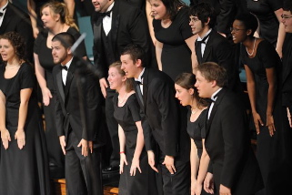
Dr. Hondorop will present a session on choral tone and phrasing with the WKU Chorale as a demonstration ensemble. Come and hear the WKU Chorale sing, learn successful techniques to assist in building beautiful choral tone and deal with phrasing issues, while earning professional development credit.

For more information contact: Dr. Jamila L. McWhirter, MTVA Collegiate Chairperson
jmcwhirt@mtsu.edu

